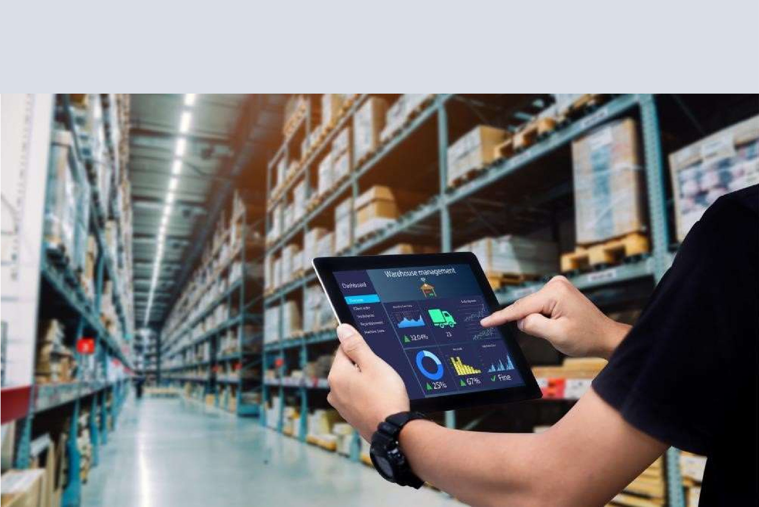

WMS Redesign

Put Away Process Understanding

Submitted by:

SIMPANA TECHNOLOGY


Putaway Cycle

- Silo Loading XML Integration: We begin the put-away process by integrating our silo loading XML. This requires a silo number in the released state, the material type, and a unique batch number. The folder number is also formatted with 'batch+silo+currentDate+sixDigitUniqueNumber'.
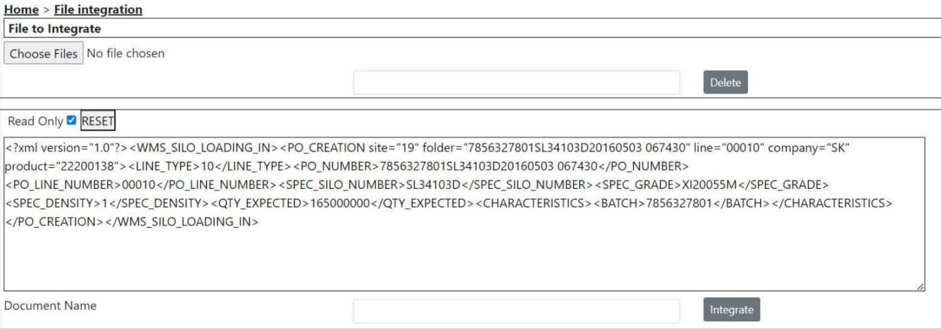

Read data from Modbus TCP client:

Requirements:
  - Jboss Application must be up and running, all ear file must be deployed
  - Modbus Server must be up and running.
  - All Silo services must be up and running.

Process:
- Open ModbusTCPClient.exe
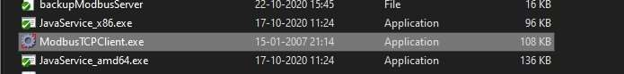

- Enter Host, if modbus server is running on localhost then provide 127.0.0.1, otherwise the system/cluster IP address.
- Enter the Port 502, and click on connect.

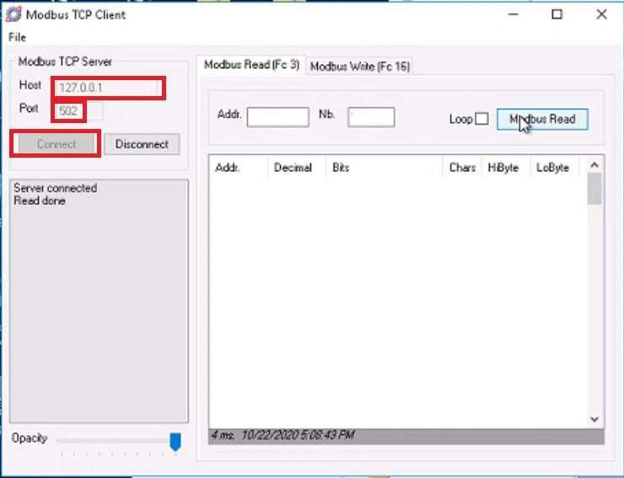

    - For reading the data for particular silo we need the address for the particular silo number, this addresses can be obtained from Modbus-Mapping excel sheet.
    - All materials have different Excel maintained with the Address of modbus.
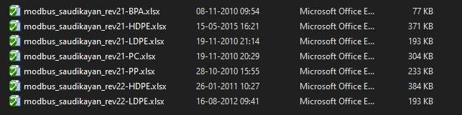

    - Let’s suppose we need to Display the data of HDPE silo SL32106A then in the Excel of HDPE material,
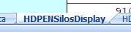

    - Locate Tab and find the Silo No in it.
    - For the Silo Number in description column there is a column of Modbus Address which is actually you need to fetch data in modbustcp client reader.
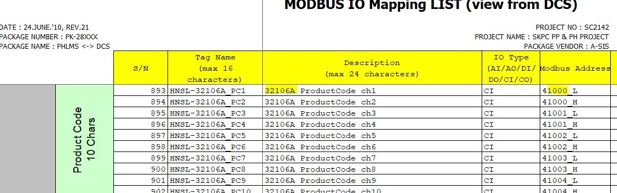

    - From the address you have to remove first value and use and rest four values.
    - Like if the address is 41000_L then we have to use only 1000.

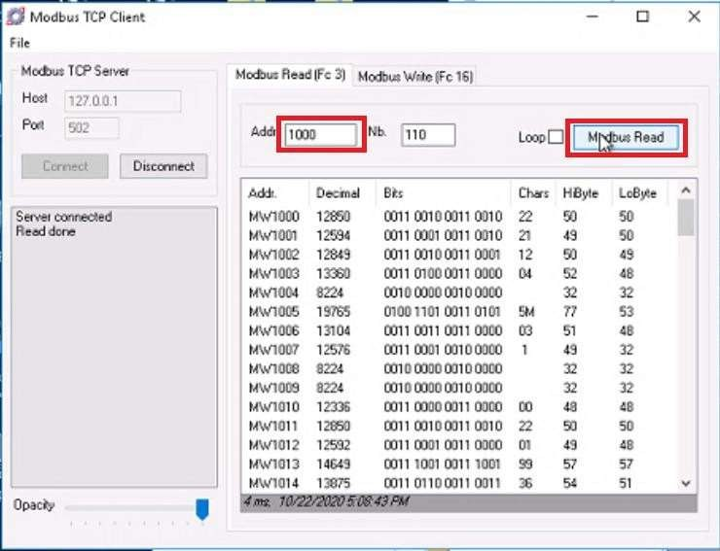
    - Data can be read from left to right from Chars column,
- For (1) IMC: 22122140 (2) Grade: M5301 (3) Batch: 0022109963
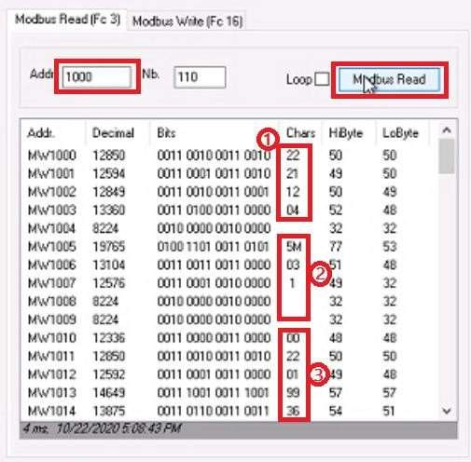

- Bits mapping is done in Excel file that which bit contain which data accordingly.

- Silo Integration & Status Check: Once the silo is integrated via the file integration menu, we check its status in the Silo menu to ensure it’s in the filling state. We then perform 'End Loading' to make the silo ready for repacking.

- Here first we take silo in “Released” state.
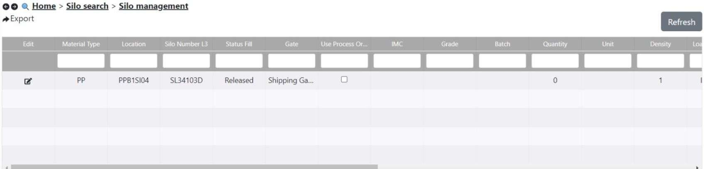

- After File Integration the silo xml silo is in Filling state.
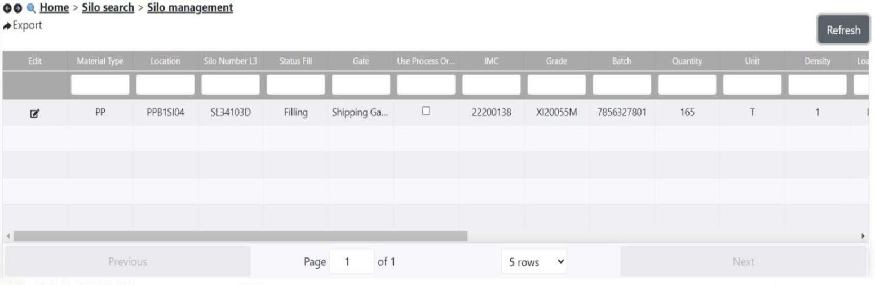

- Here we end the loading of silo.
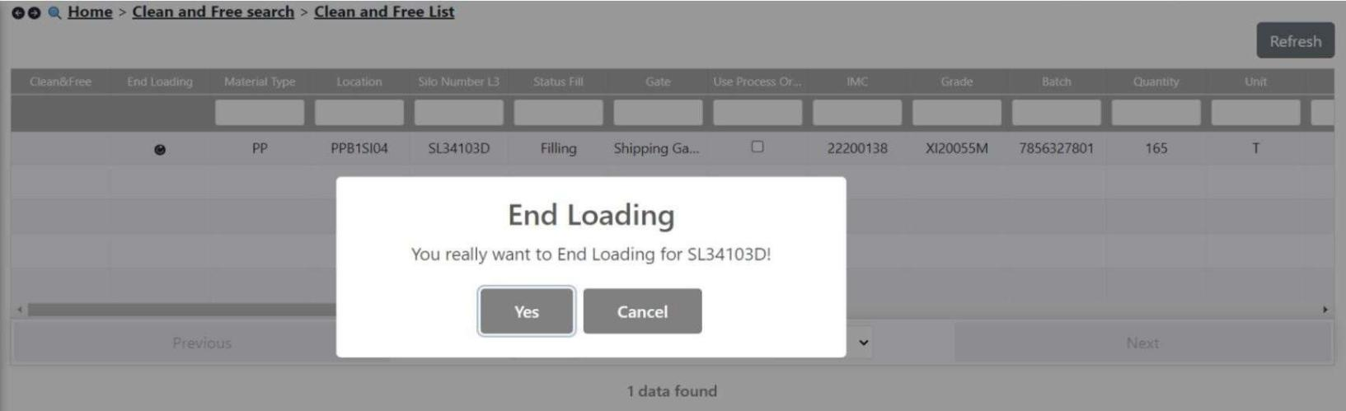

- Silo is in “Filled” state.
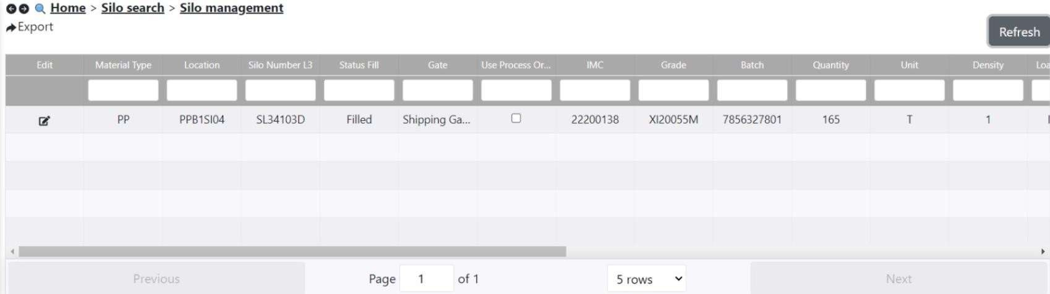

- Repacking XML Integration: Next, we integrate our Repacking XML to create containers. We need to gather data such as the batch number, silo number, and IMC, along with a unique 7-digit folder ID. The XML is then edited with this information and integrated."

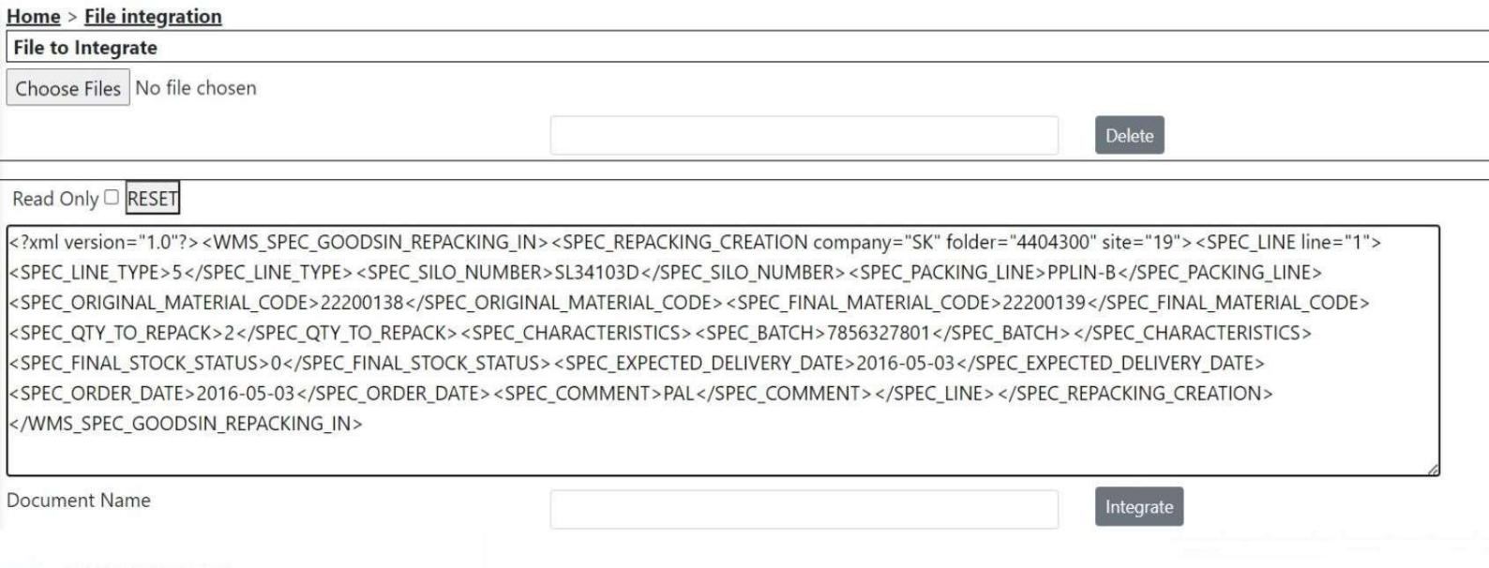
- Repacking Process & DCS Confirmation: After integration, we check the status in the Silo > Repacking menu, filter with the folder ID, and confirm the process by sending it to DCS. The folder ID should be in the 'in-progress' state before proceeding.

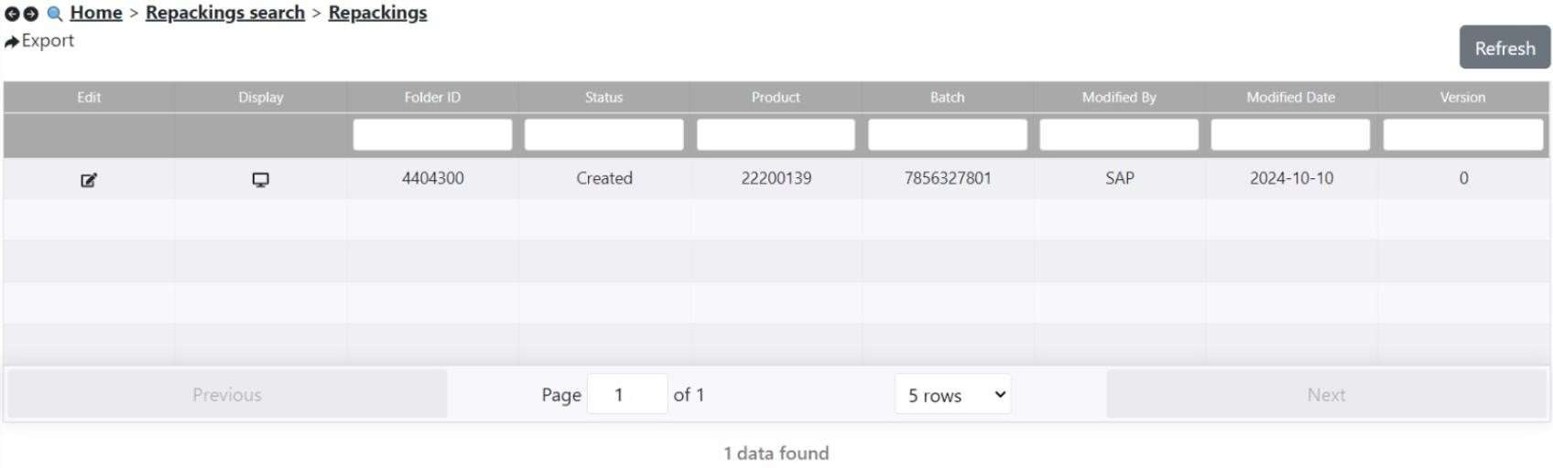

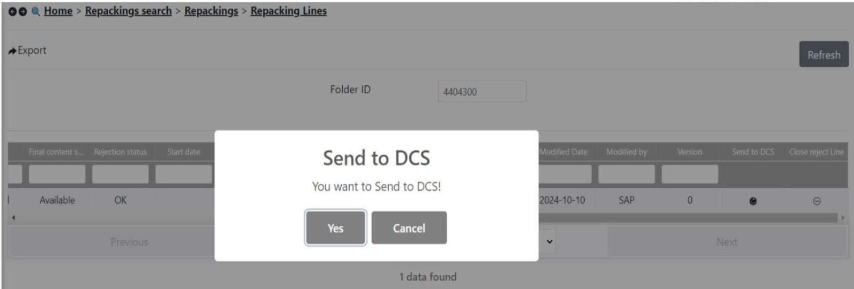

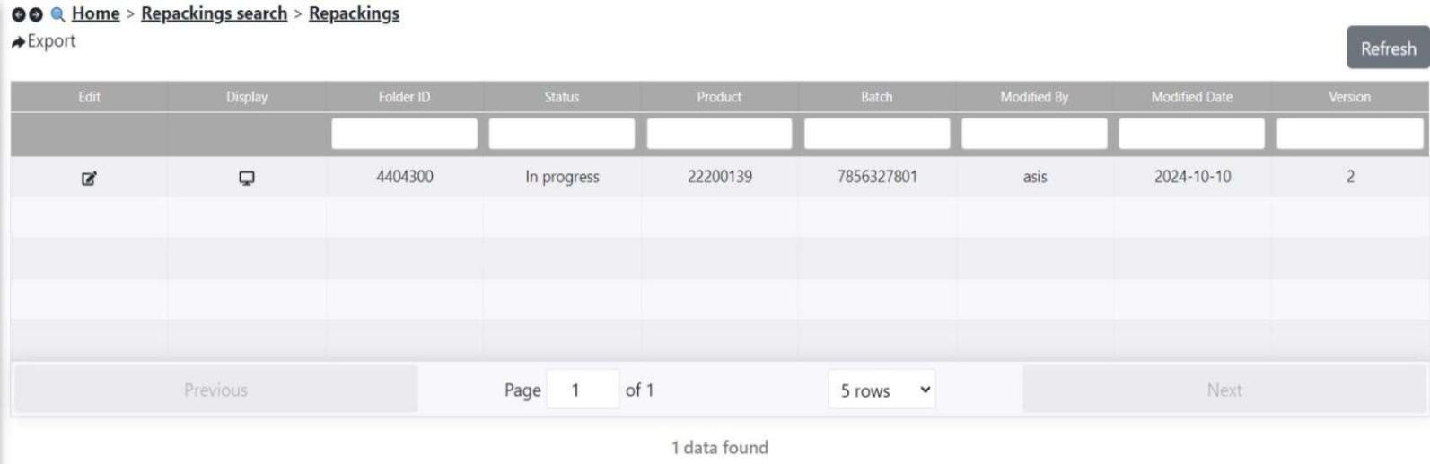

- Prod Container Creation: Using the WMS_RADIO application, we log in and navigate to the Repacking menu to create production containers. We enter the folder ID, confirm the packing line and silo, and input container numbers as needed."
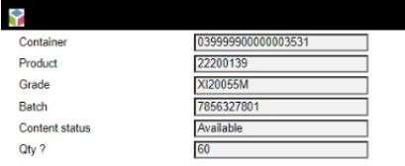

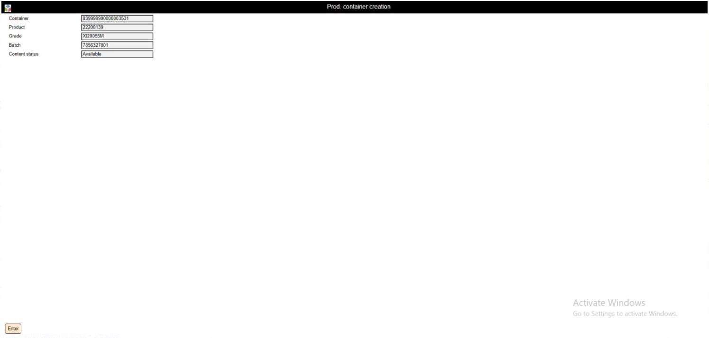
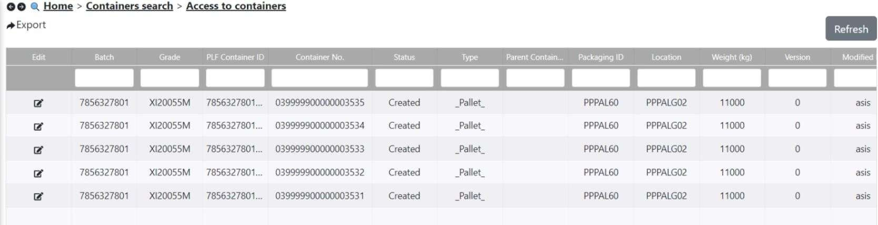

- Container Validation: We validate the containers by entering their numbers one by one in the Modify Prod Containers menu. We then check their status in the PHLMS application to ensure they are in a 'validated' state.
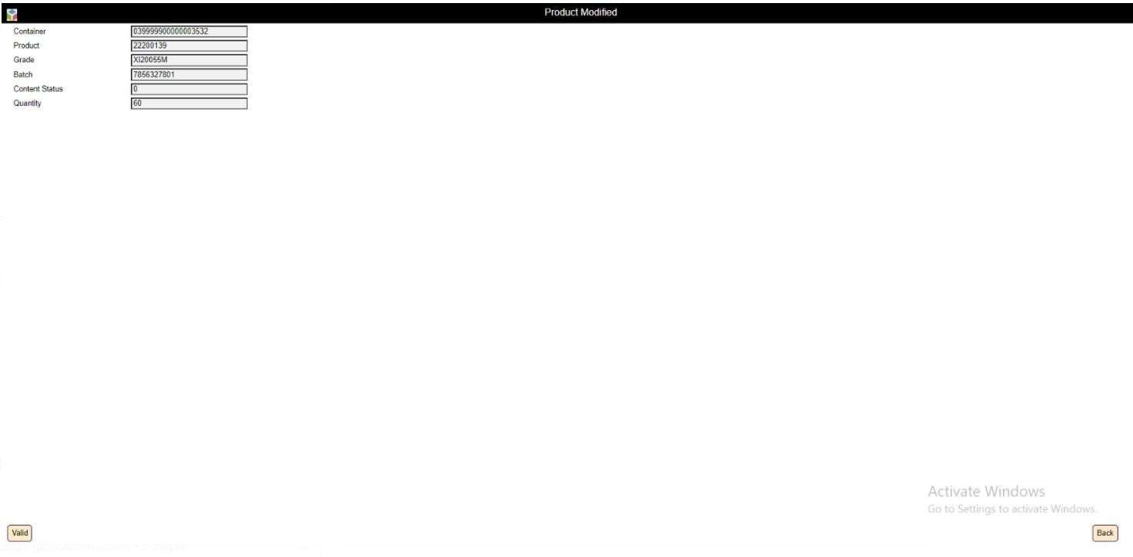

- Trolley Loading : To begin the put-away process, we go back to the WMS_RADIO application, select Mission > Load Trolley, enter a new trolley number, and load the containers. After that, we unload the trolley to a new location.
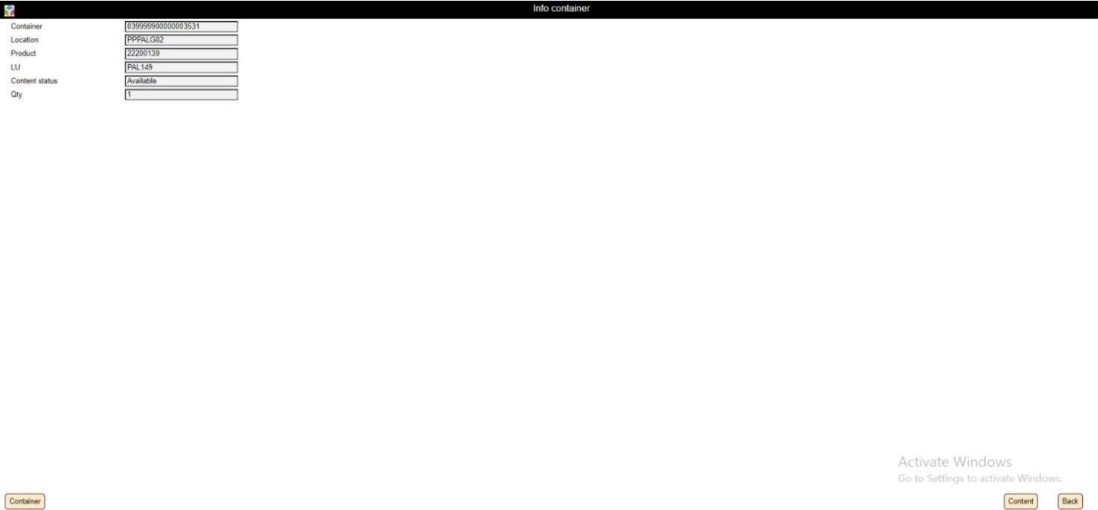

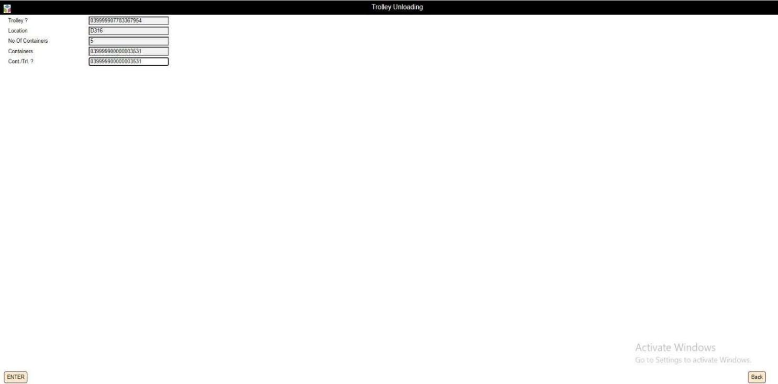
- Completing the Put-Away Process: Finally, after unloading the trolley, we check the container locations in the PHLMS application to confirm they have been correctly put away.


